dim_imdb_titleType & dim_imdb_title_basics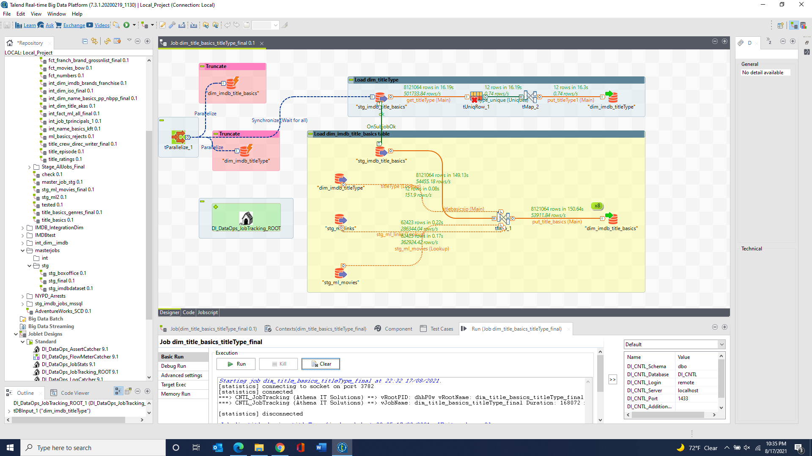

dim_imdb_brand & dim_imdb_Franchise 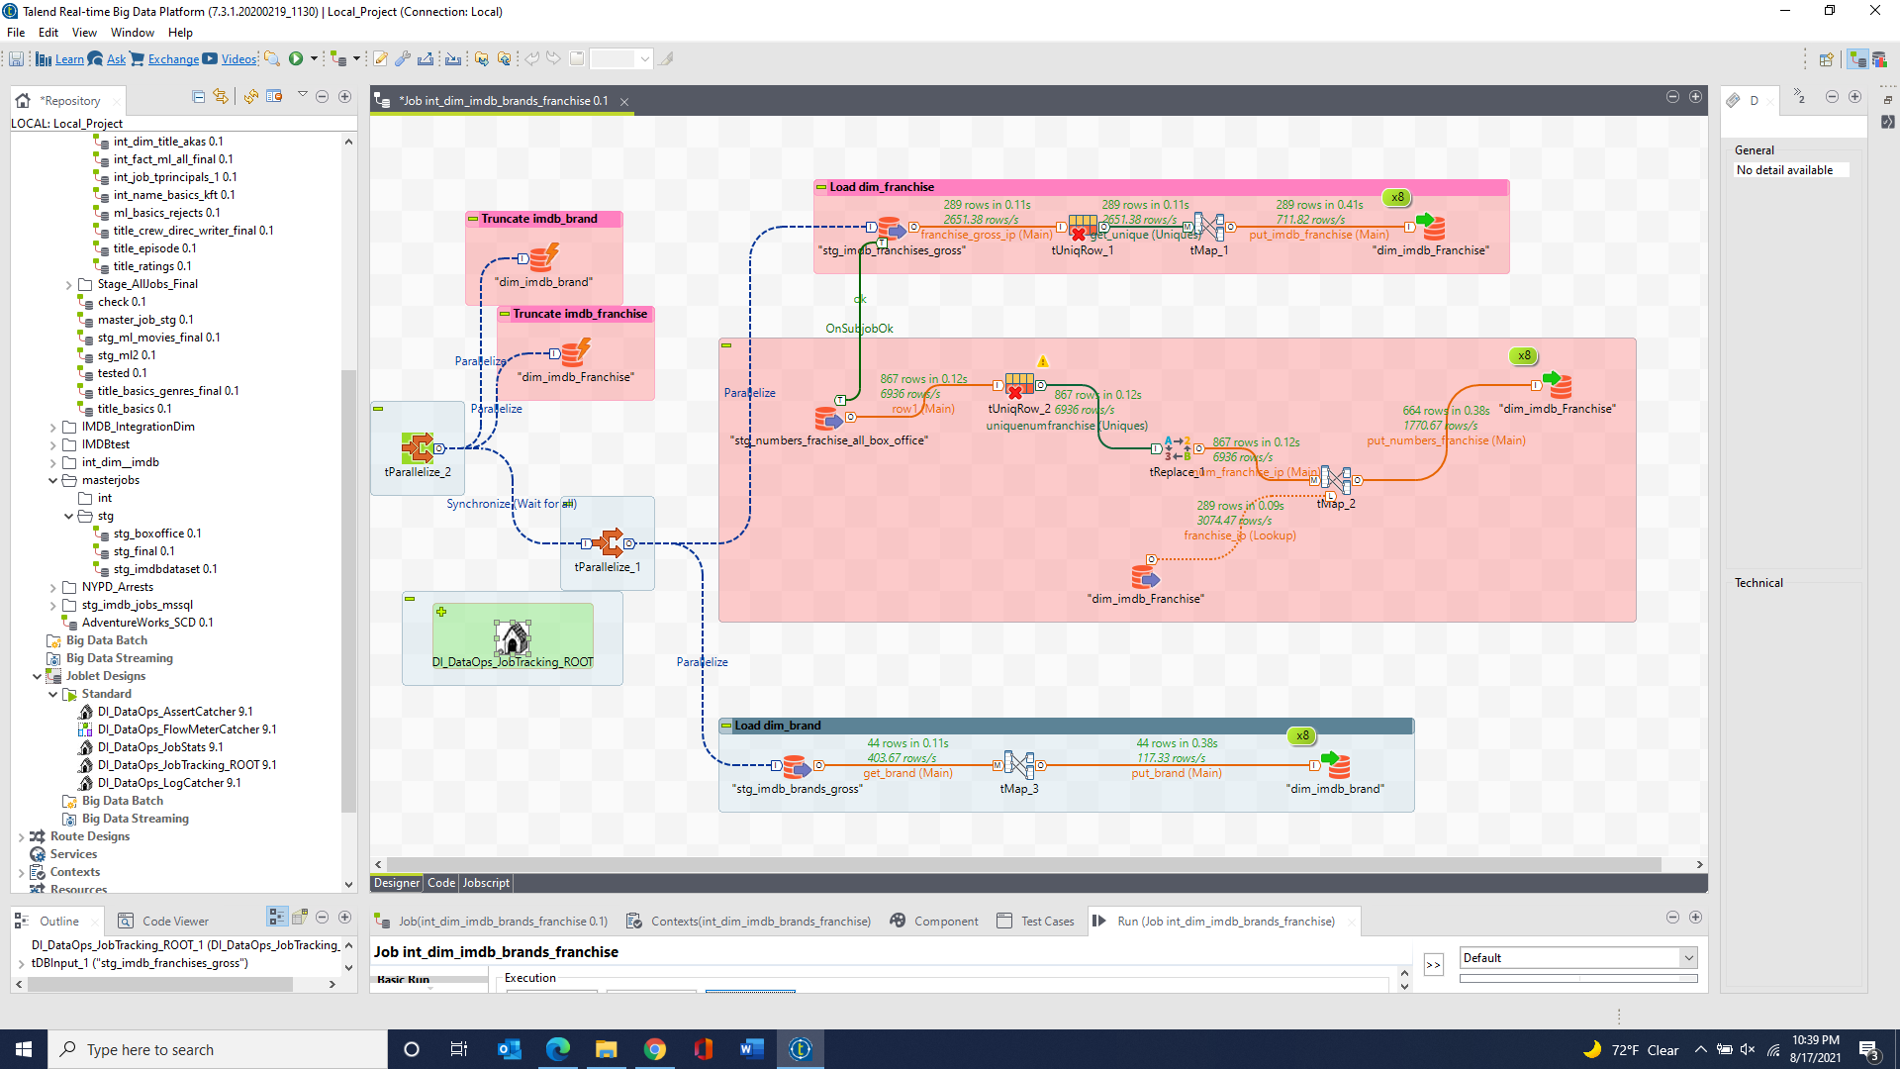

dim_imdb_name_basics & dim_imdb_primaryProfession & dim_imdb_name_basics_primaryProfession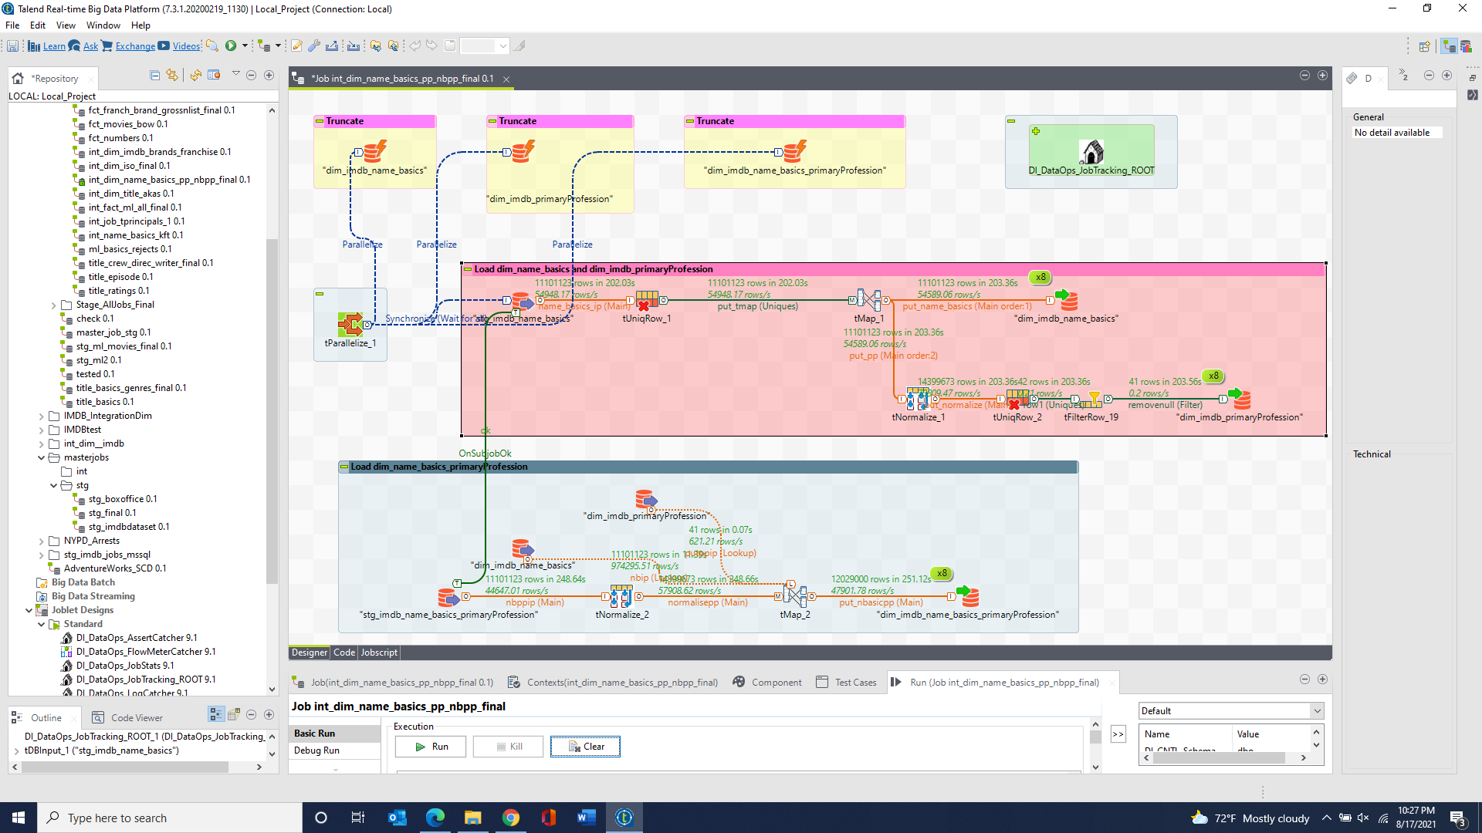

dim_imdb_name_basics_knownForTitles & dim_imdb_name_basics_knownForTitles_rejects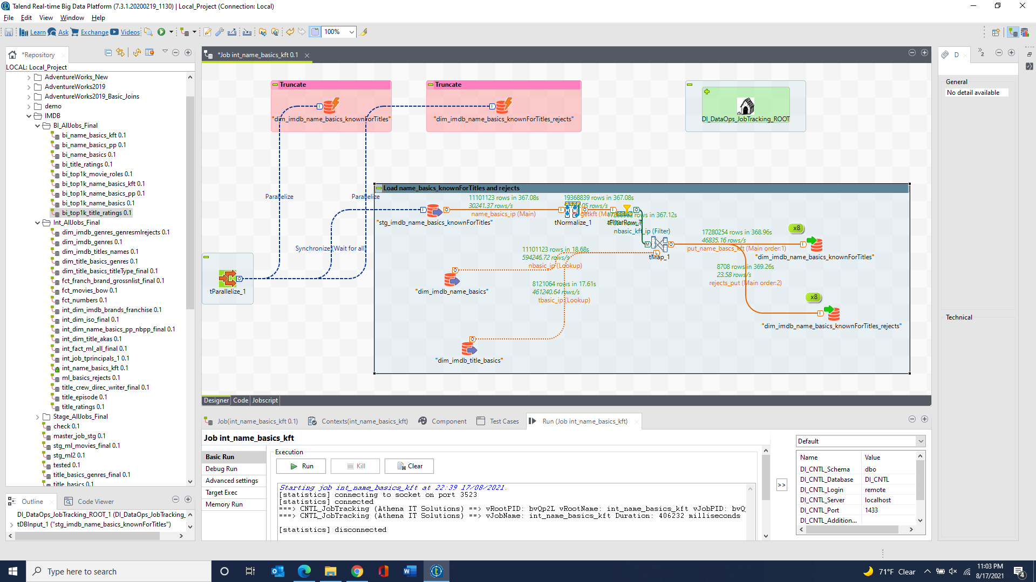

dim_iso_country & dim_iso_language 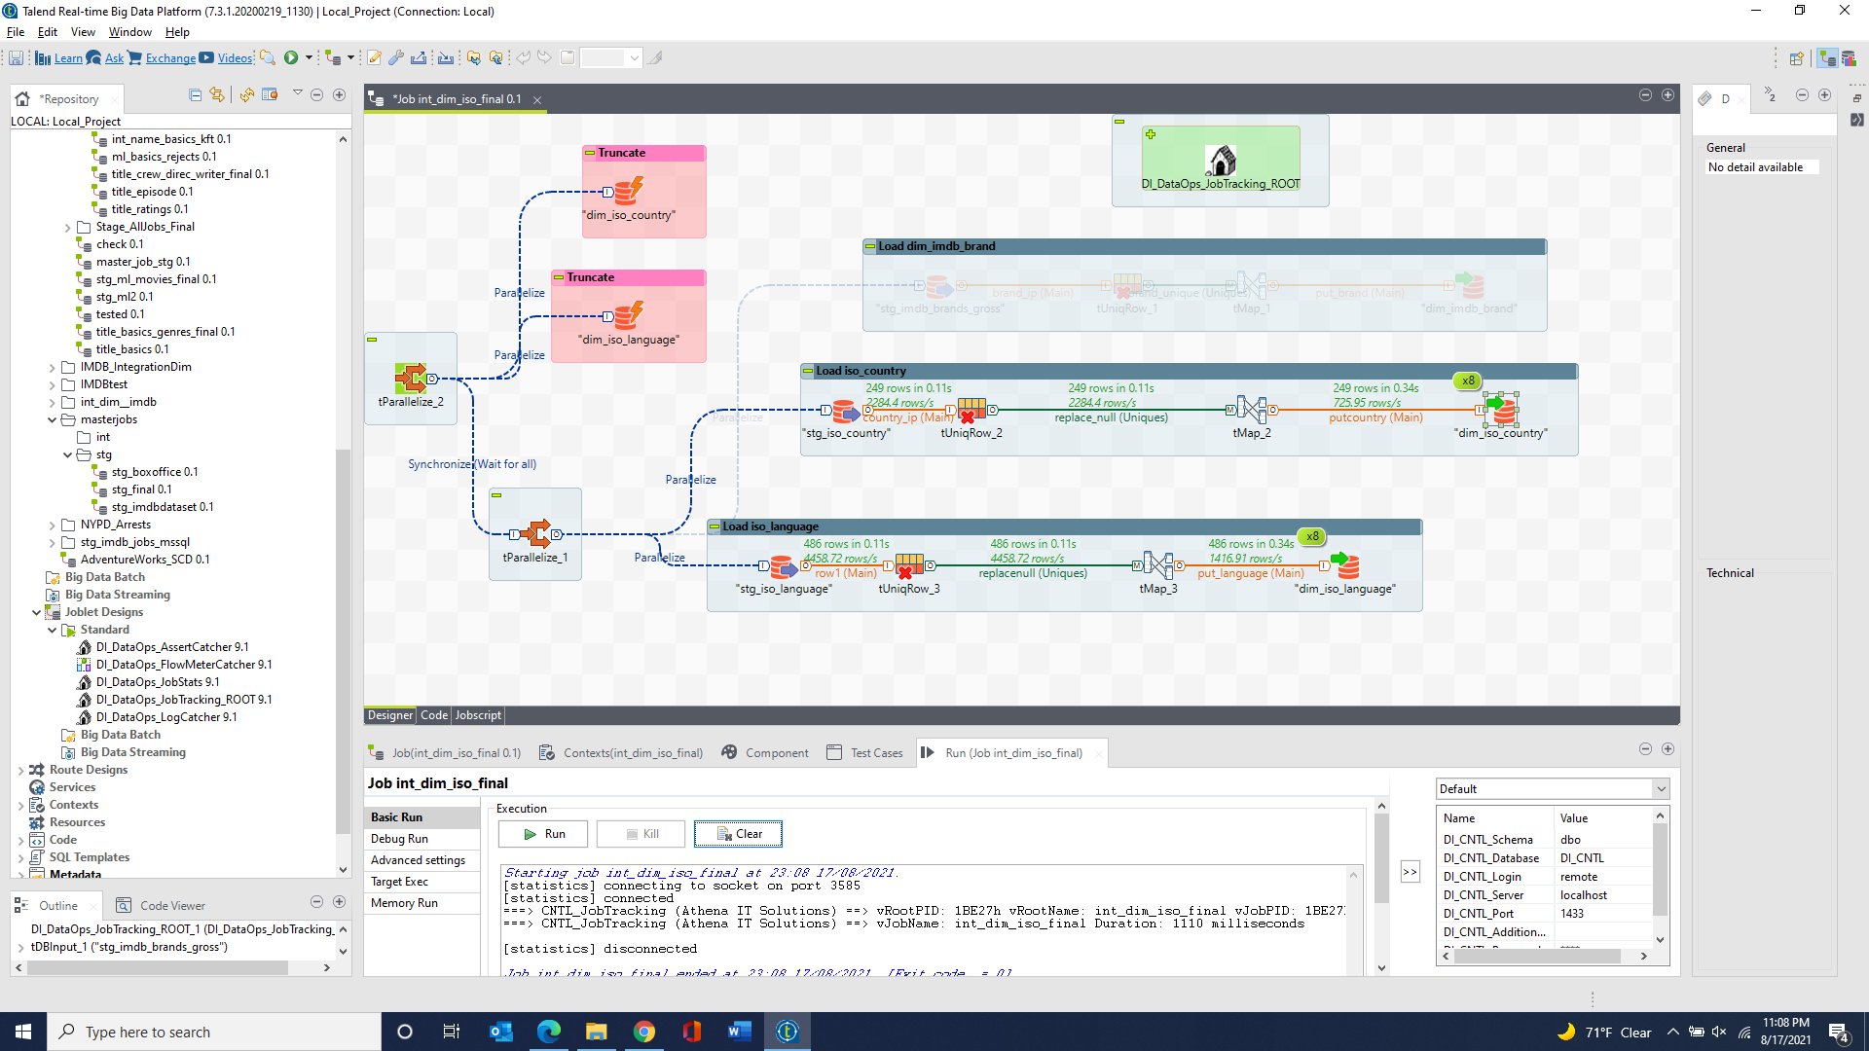

dim_imdb_title_akas & dim_imdb_title_akas_rejects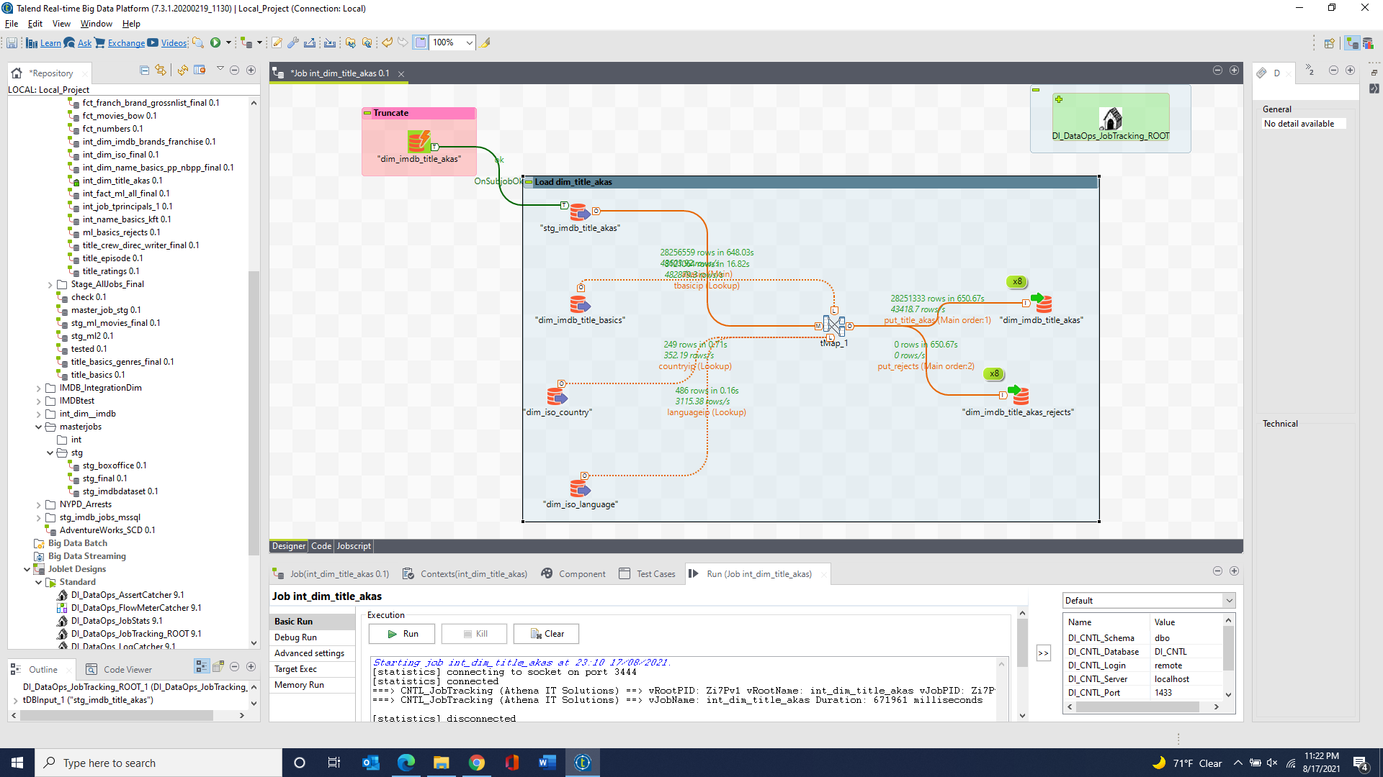

dim_imdb_genres & dim_imdb_genres_ml_rejects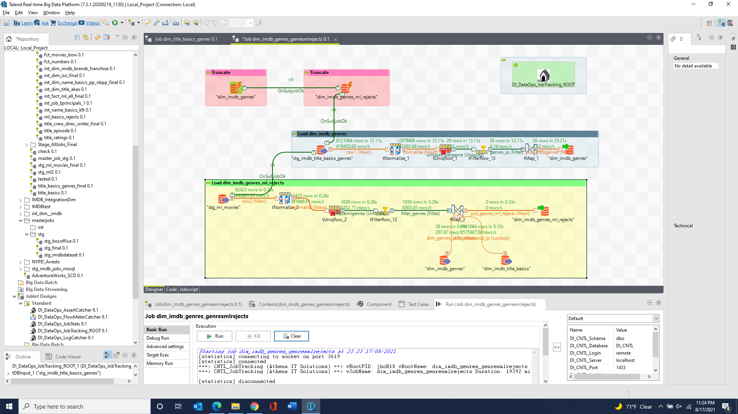

dim_imdb_title_basics_genres 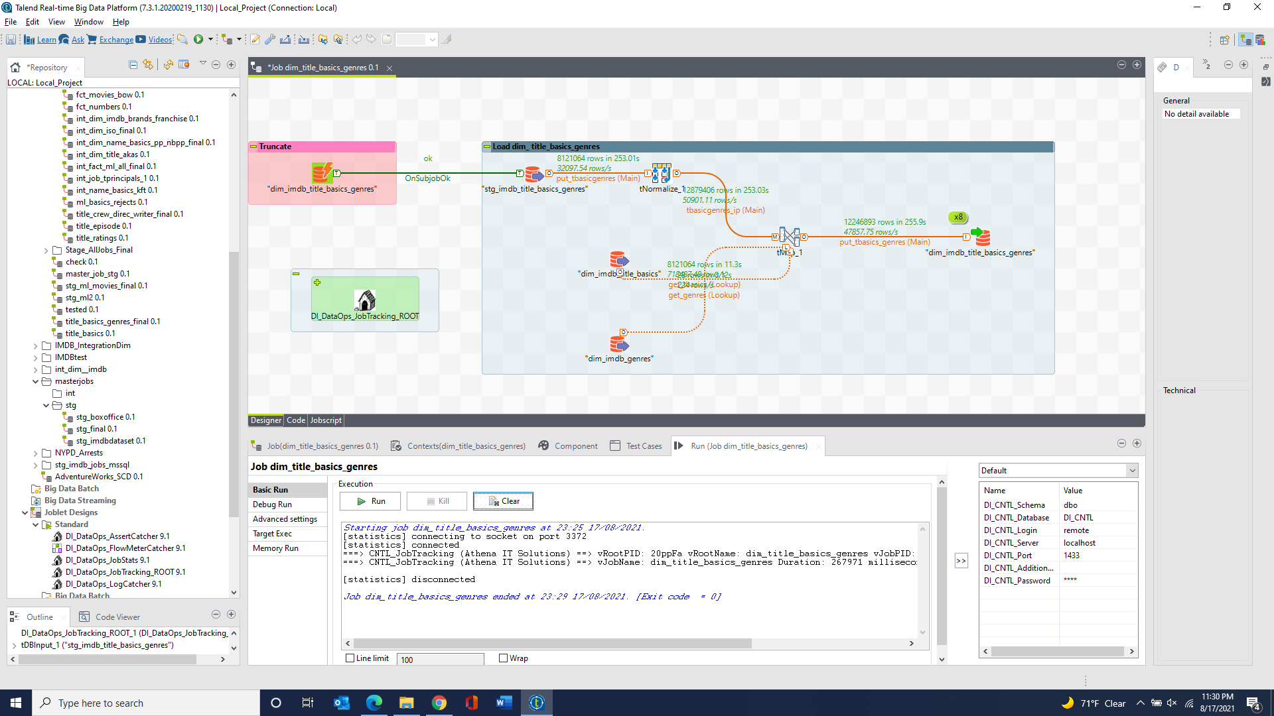

dim_imdb_title_crew_directors & dim_imdb_title_crew_directors_rejects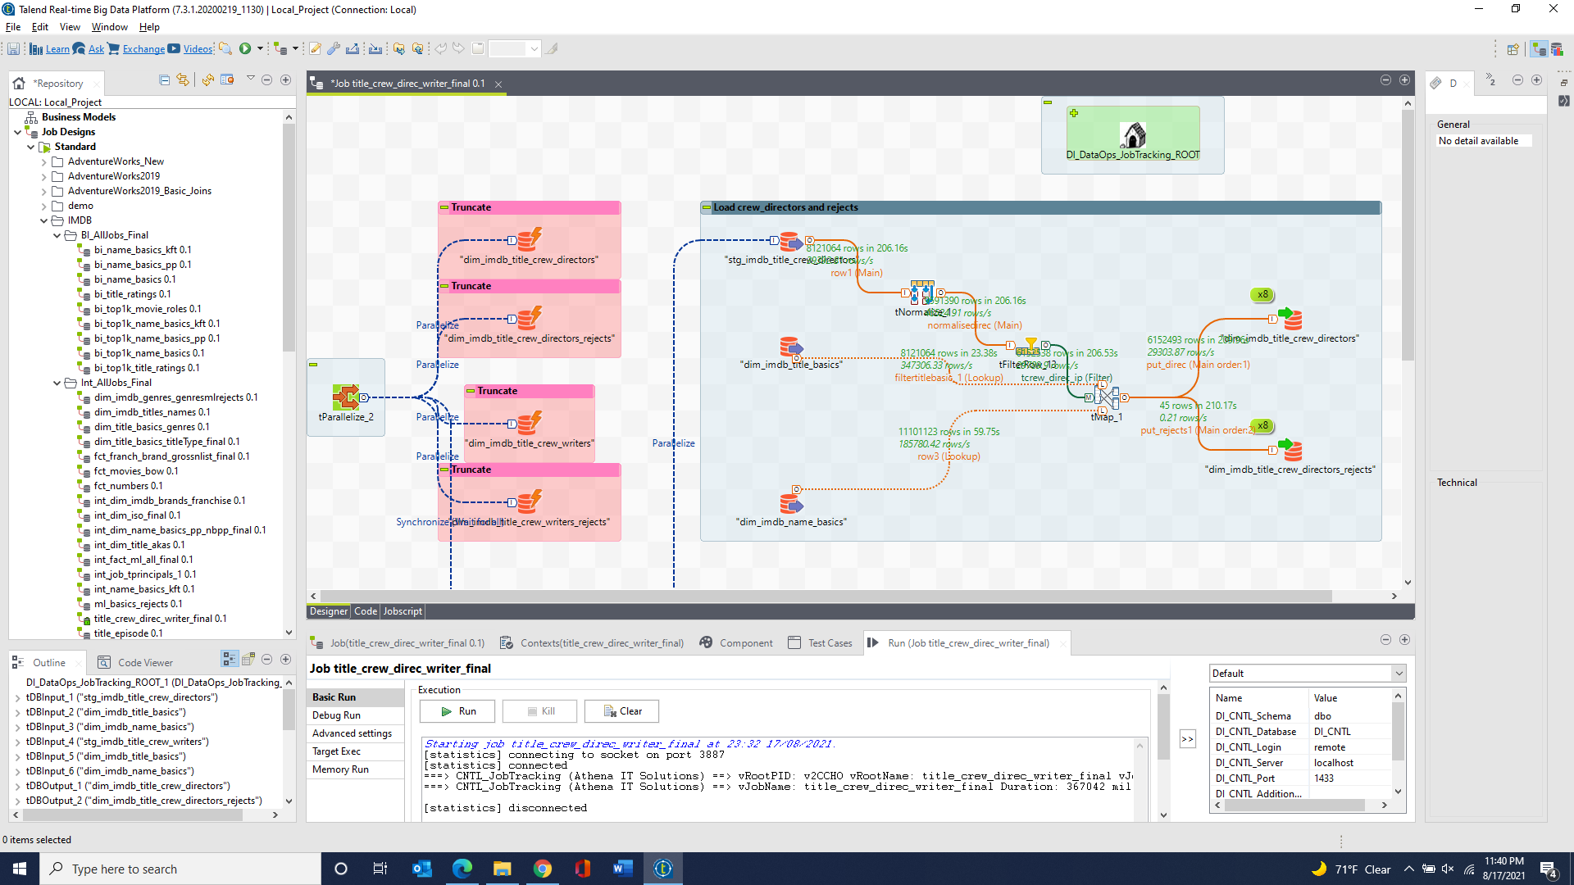

dim_imdb_title_crew_writers & dim_imdb_title_crew_writers_rejects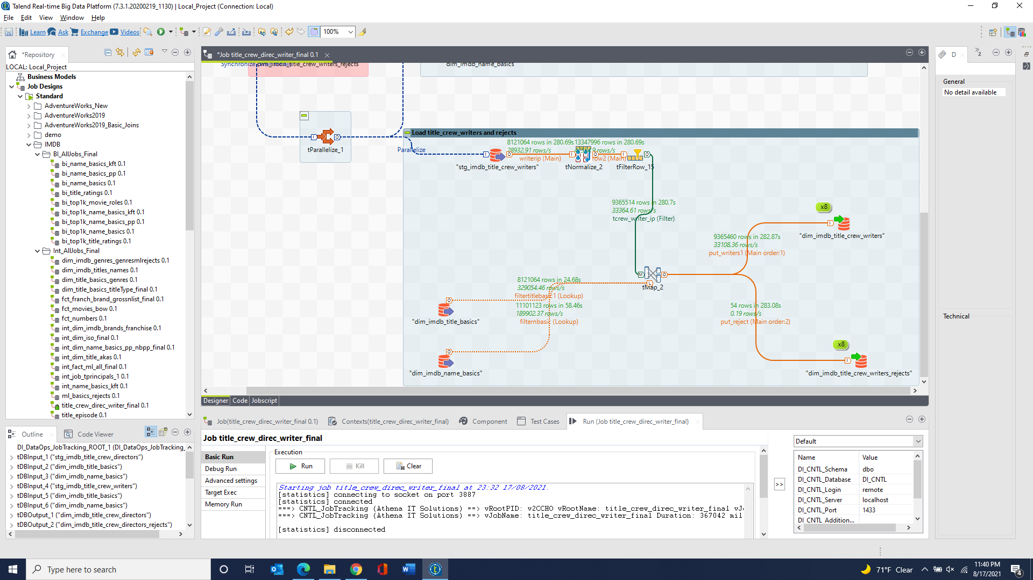

dim_imdb_title_episode & dim_imdb_title_episode_rejects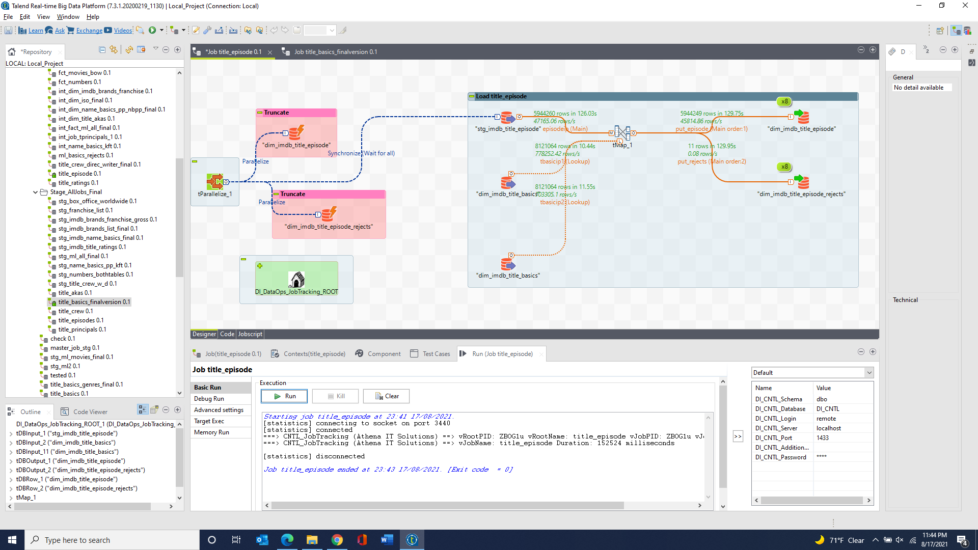

dim_imdb_job_category & dim_imdb_title_principals & dim_imdb_title_principals_rejects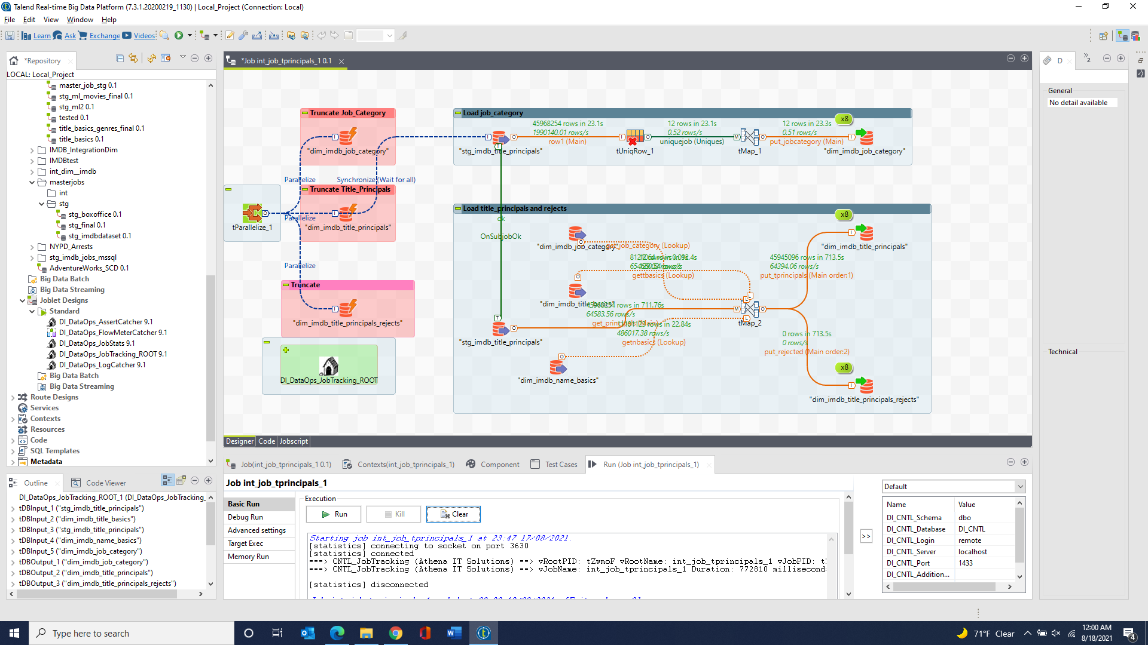

fct_imdb_title_ratings 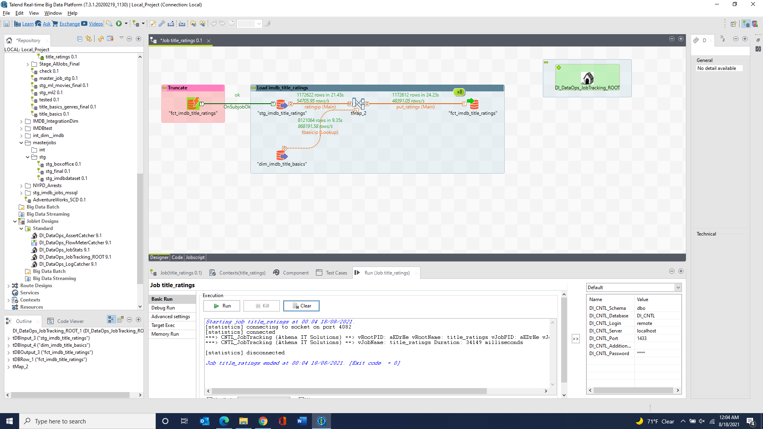

fct_numbers_daily_box_office & fct_numbers_franchise_all_box_office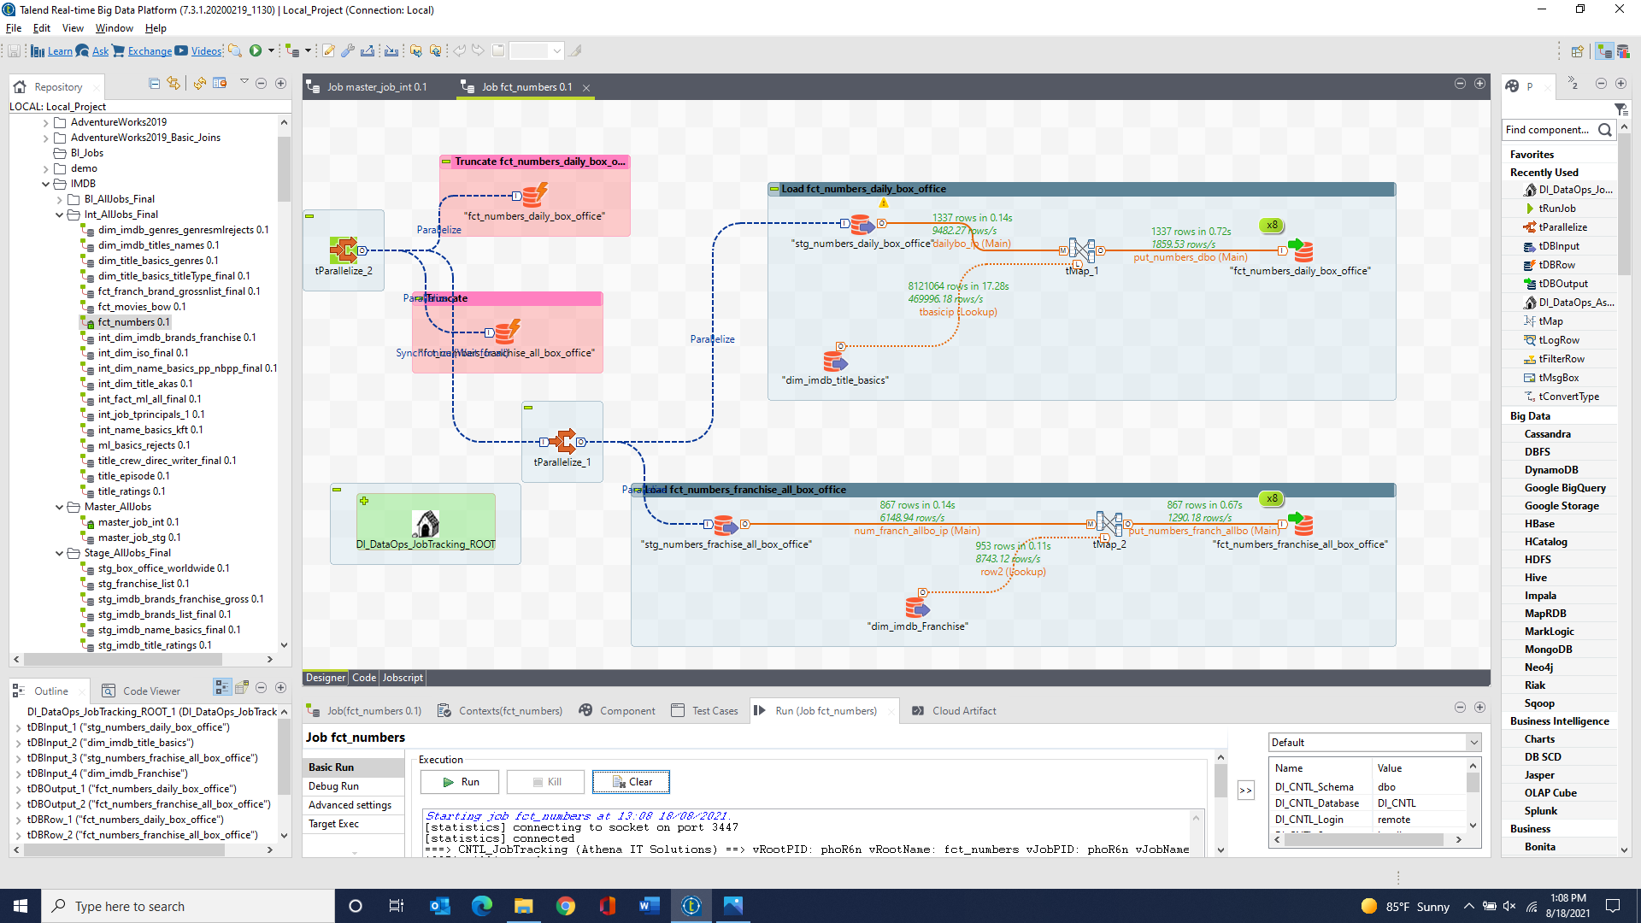

fct_ml_genome_scores & fct_ml_ratings & fct_ml_genome_scores_rejects & fct_ml_ratings_rejects & fct_ml_tags & fct_ml_tags_rejects & fct_ml_genome_tags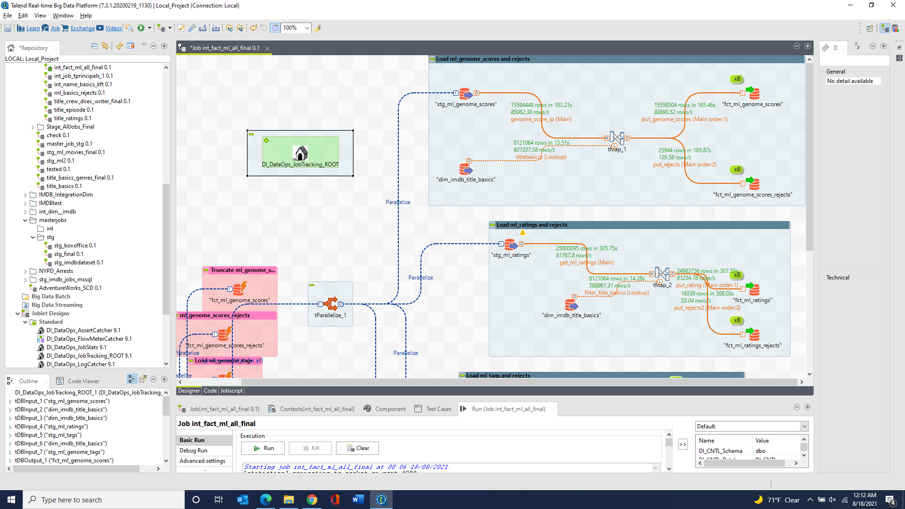 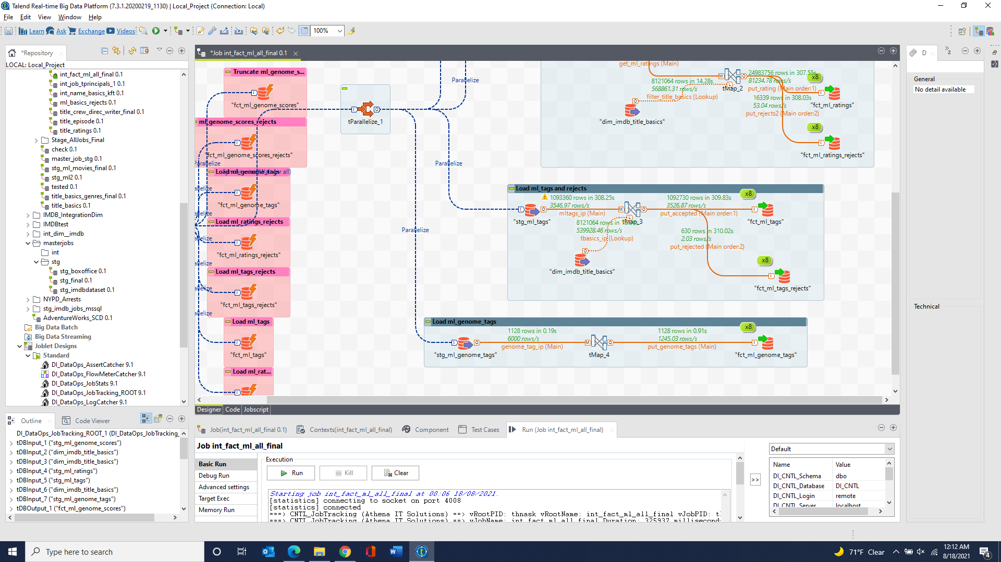

fct_imdb_brands_gross & fct_imdb_brands_list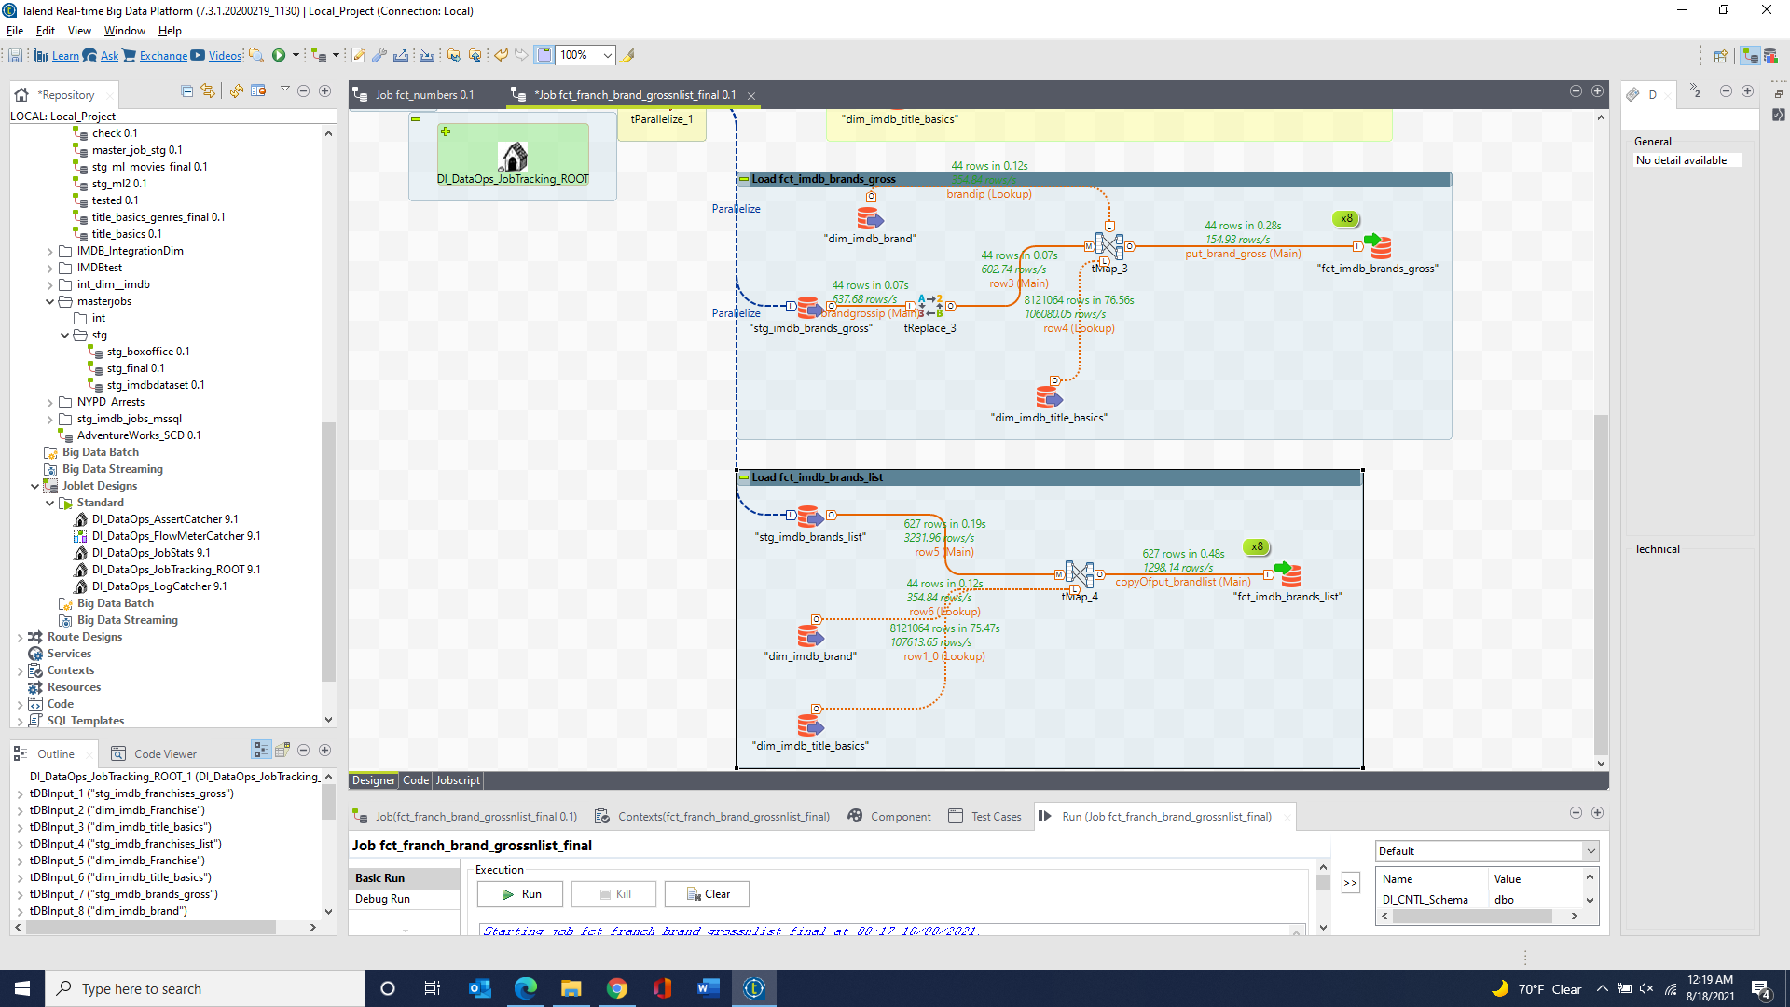

fct_imdb_franchises_gross & fct_imdb_franchises_list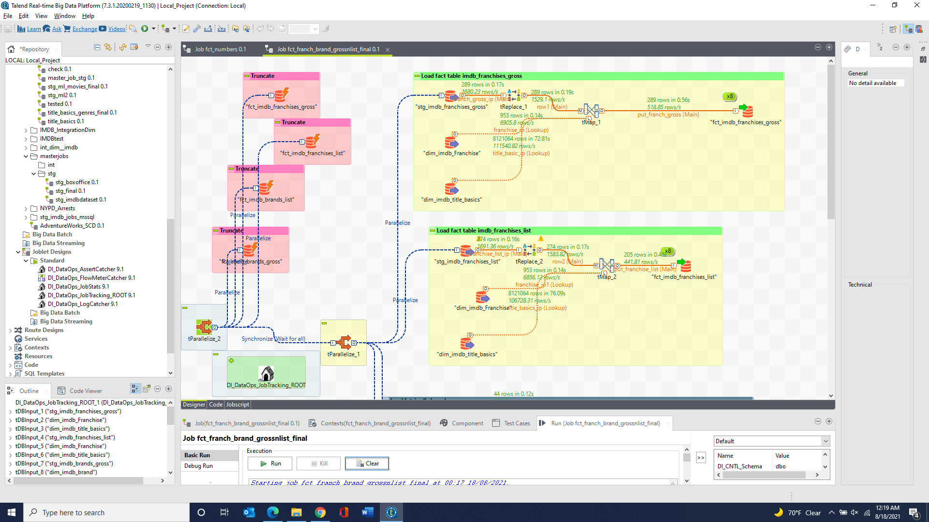

dim_imdb_title_basics_ml_rejects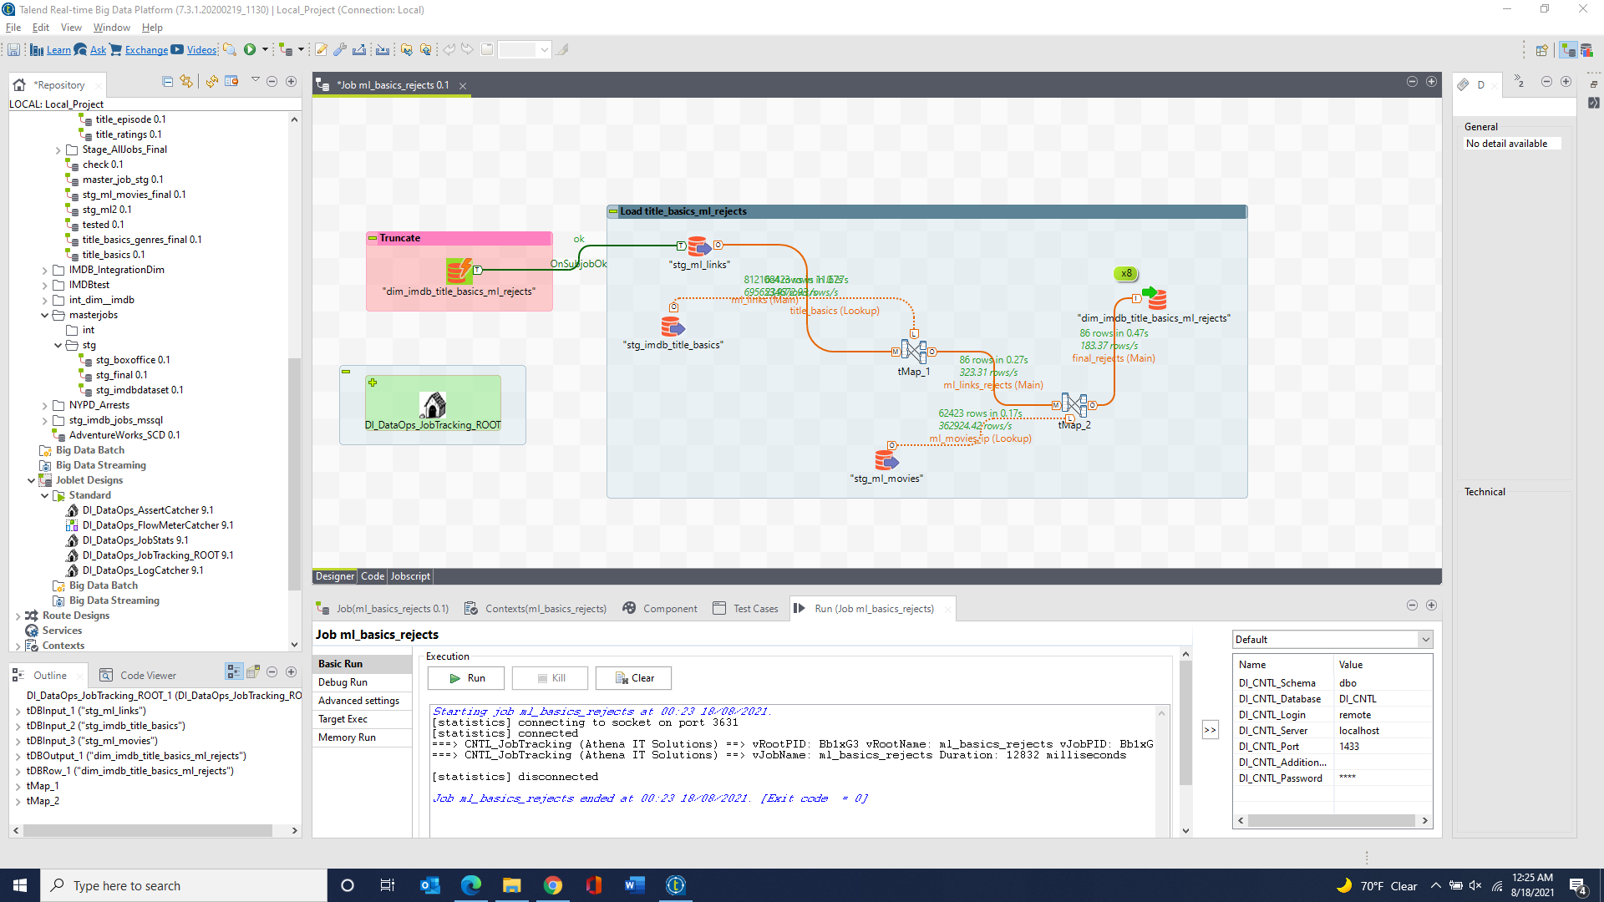

fct_movies_box_office_worldwide & fct_movies_box_office_worldwide_rejects